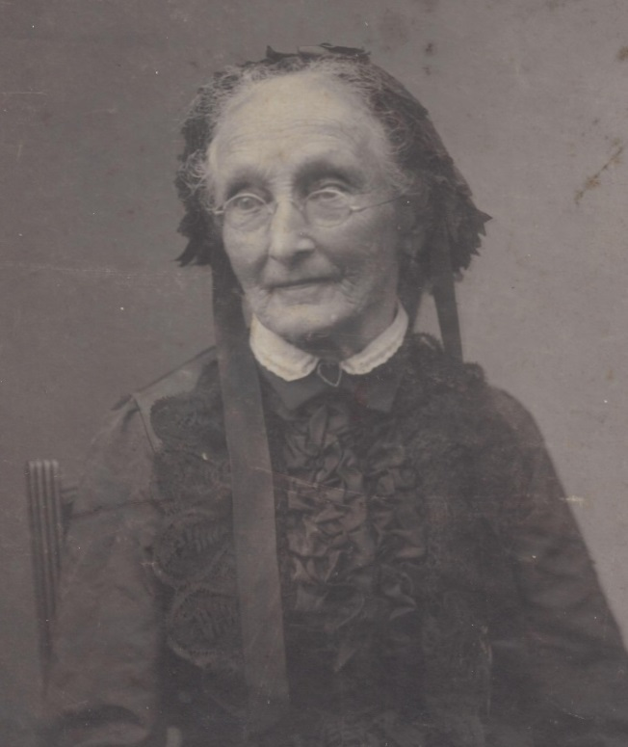

Lavina Thompson Foster, wife of Charles Foster - about 1900 (est.)

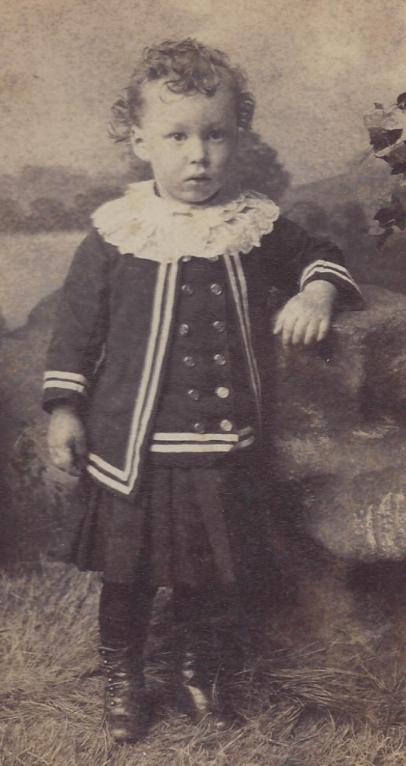

Harry Hall Foster (1884-1910), Mary Helen Foster

Wolfe’s half-brother – about 1887 (est.)